**PCO Connect**

Technical User Guide

Version 1.0 | August 2025

**System User Manual**

| **NAME** | TEACH WITH TVV GROUP |
| --- | --- |
| **COMPANY** | THE INFORMATION SCHOOL, UNIVERSITY OF WASHINGTON - SEATTLE |
| **DEPARTMENT** | MSIM PROGRAM - EARLY-CAREER ACCELERATED TRACK, RESIDENTIAL |
| **DATE** | AUGUST 20, 2025 |

# **I. Introduction**

**PCO Connect** is an educational and action-oriented website designed to help Washington residents, especially young voters, understand and engage with the role of Precinct Committee Officers (PCOs). It aims to demystify local political structures, empower civic participation, and provide clear tools to get involved in grassroots politics. By bridging technology and civic education, the platform makes it easier for users to learn, connect, and take meaningful action within their communities.

## **1. About Teach With TVV**

**Teach with TVW** is a civic education initiative produced by TVW, Washington State’s public affairs network. Its mission is to enhance civic literacy among K–12 students and young adults across Washington by offering free tools such as explainer videos, lesson plans, live Q&A sessions with state leaders through the TVW CONNECTS program, and interactive resources.

## **2. Purpose of this Manual**

The purpose of this manual is to provide stakeholders with a clear, step-by-step resource for navigating and utilizing the PCO Connect platform effectively. This guide explains how the site is organized, what features are available, and how each tool supports civic learning and engagement.

By following this manual, stakeholders will gain the ability to:

* Understand the goals and functions of PCO Connect in the broader context of civic education
* Navigate the website independently with confidence
* Use the platform’s tools to locate Precinct Committee Officers (PCOs), learn about their role, and explore pathways for participation
* Troubleshoot common issues or challenges that may arise during site use

This manual is designed to serve both new and experienced users. For those unfamiliar with grassroots political structures, it provides accessible explanations of key terms and processes. For more advanced users, it highlights ways to leverage PCO Connect as a resource for education, outreach, and community empowerment.

# **II. Getting Started**

Before diving into the functionalities of **PCO Connect**, it's essential to familiarize yourself with the basics. This section guides you through the initial setup process and provides an overview of the system's interface and navigation.

## **1. Access the Platform**

To get started, follow these steps:

* Open your preferred web browser (Chrome, Firefox, Safari, or Edge) and visit: [**https://tvw.netlify.app/**](https://tvw.netlify.app/)
* The site is fully functional on both desktop and mobile devices. No login or software installation is required

## **2. Interface Overview**

Once the site loads, you'll be greeted with the main dashboard, which serves as the central hub for accessing various features and functionalities. Key components of the interface include:

* **Navigation Bar (top of the page)**: Links labeled *What is a PCO?*, *Party Platforms*, *Become a PCO*, *Find Your Precinct*, and *Resources*. These help you quickly access each section



* **Main Banner Section:** Civic message introducing the knowledge gap about PCOs among young voters, with call-to-action buttons linking directly to functional pages

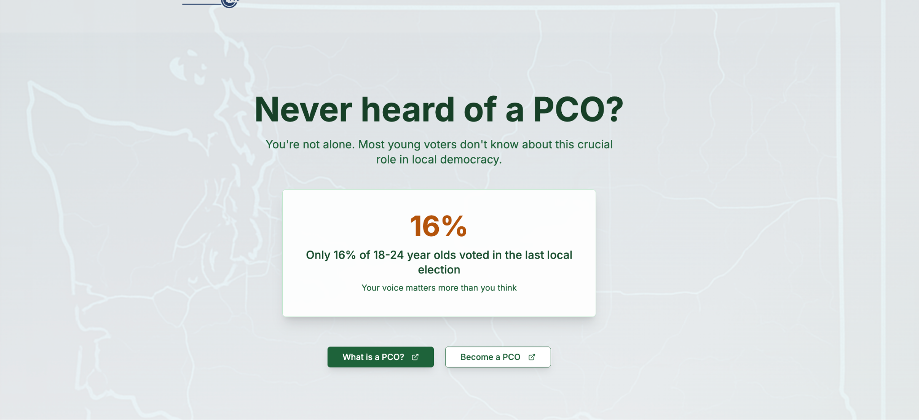

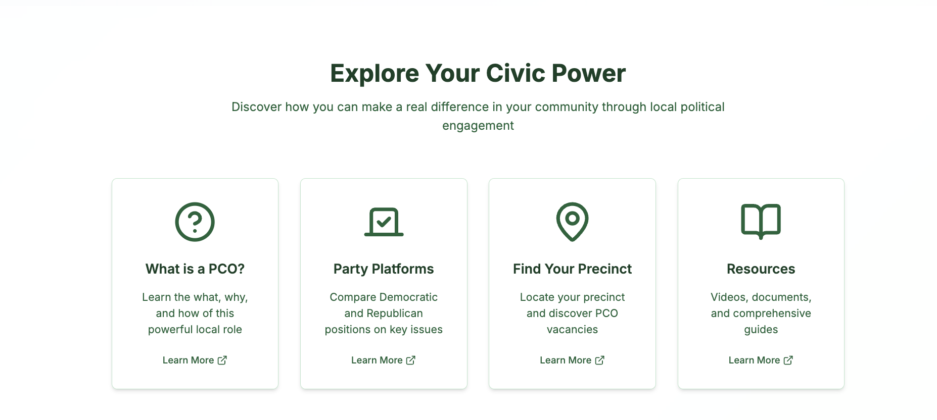

* **Quotes from PCOs:** Testimonials from existing PCOs across Washington counties, which add legitimacy and showcase impact

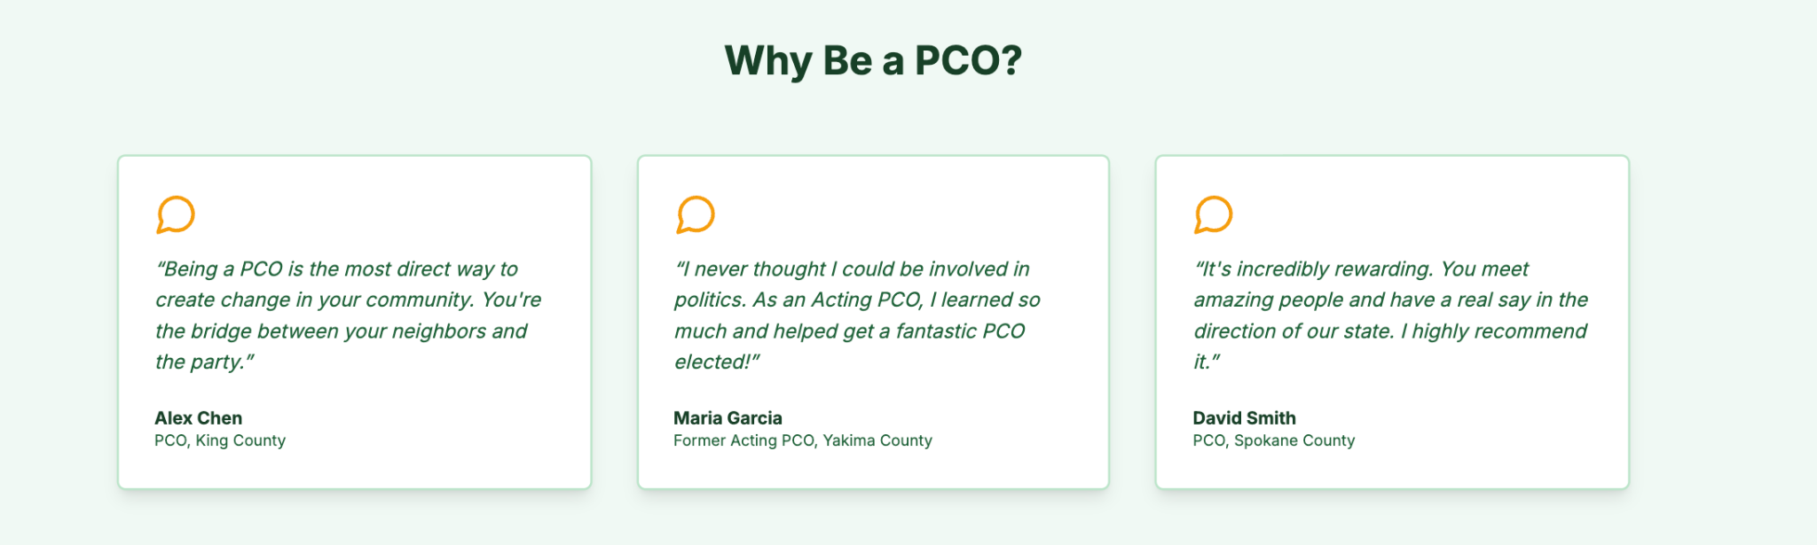

* **Footer Section:** Contains mission branding, quick links, and references to TVW and Washington State parties

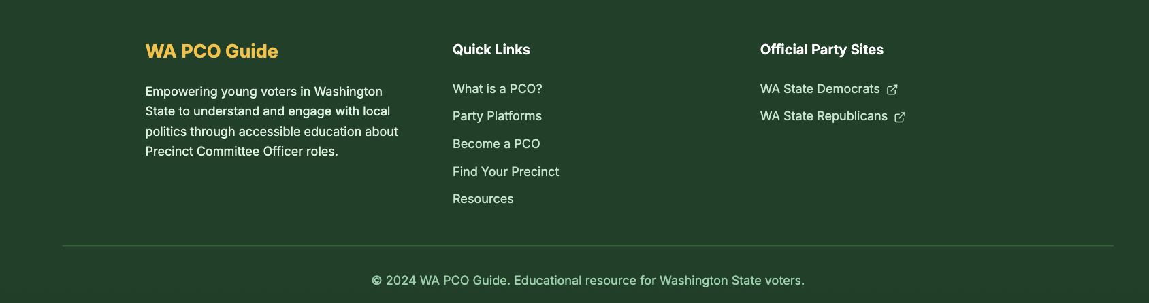

# **III. System Features**

Now that you've familiarized yourself with the basics, let's explore the key features and functionalities of the PCO Connect platform. This section will provide you with detailed instructions on how to perform various tasks and utilize the system's capabilities to their fullest potential.

## **1. Feature 1: What Is a PCO?**

This section provides visitors with a clear, comprehensive understanding of the **Precinct Committee Officer (PCO)** role, highlighting responsibilities, importance, and practical opportunity for civic engagement.

### **1.1 Page Title & Introduction**

* **Header**: “Precinct Committee Officer” labels the page
* **Tagline**: Emphasizes the PCO role as “the grassroots foundation of political parties in Washington State” and how they connect communities to government

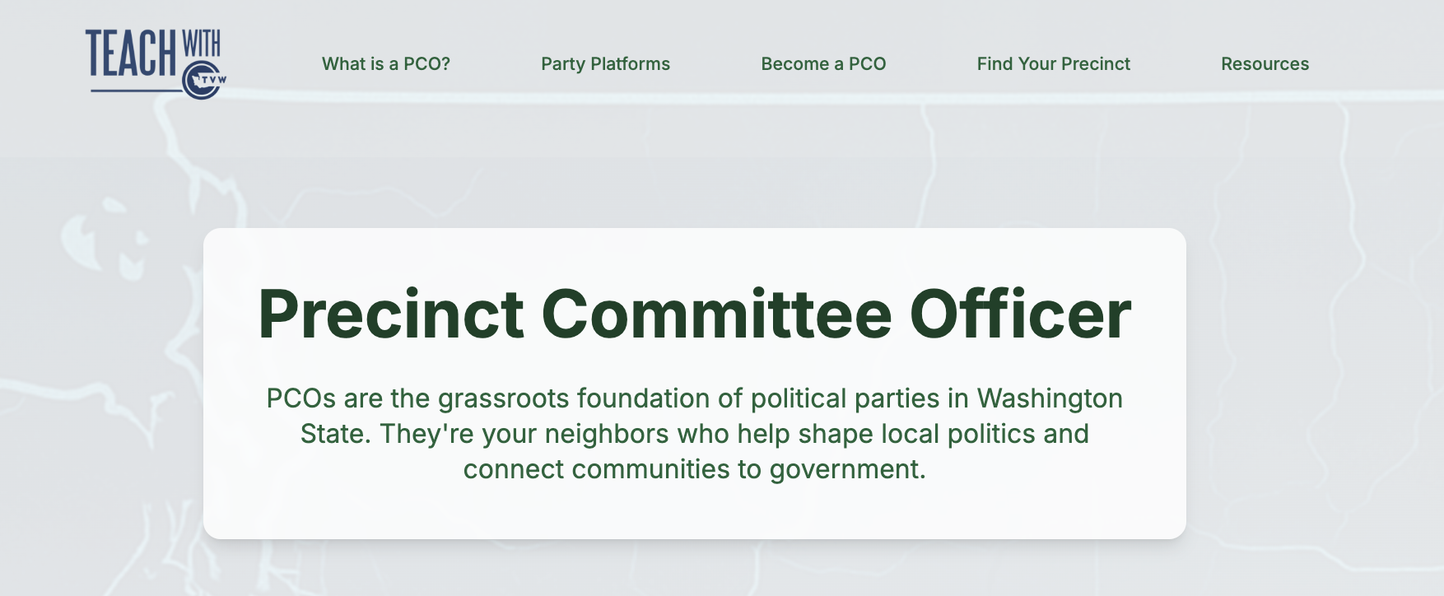

### **1.2 Core Content**

PCO responsibilities are organized into three categories for user clarity:

* **Community Outreach:** Connect with neighbors, organize events, register voters, share candidate and ballot information
* **Party Leadership:** Vote on endorsements and resolutions, elect county leaders, participate in conventions, select delegates
* **Advocacy & Action:** Champion local issues, support candidates, encourage voter turnout, bridge communities with government branches

**1.3 Impact & Opportunity**

This section underscores the importance of confirming precinct information and local representation.

* Washington State has **7,500 precincts** and up to **2 PCO positions per party per precinct**, meaning roughly **30,000 positions** could be filled
* Approximately **40% of PCO roles remain vacant**, signaling vast opportunity for civic participation

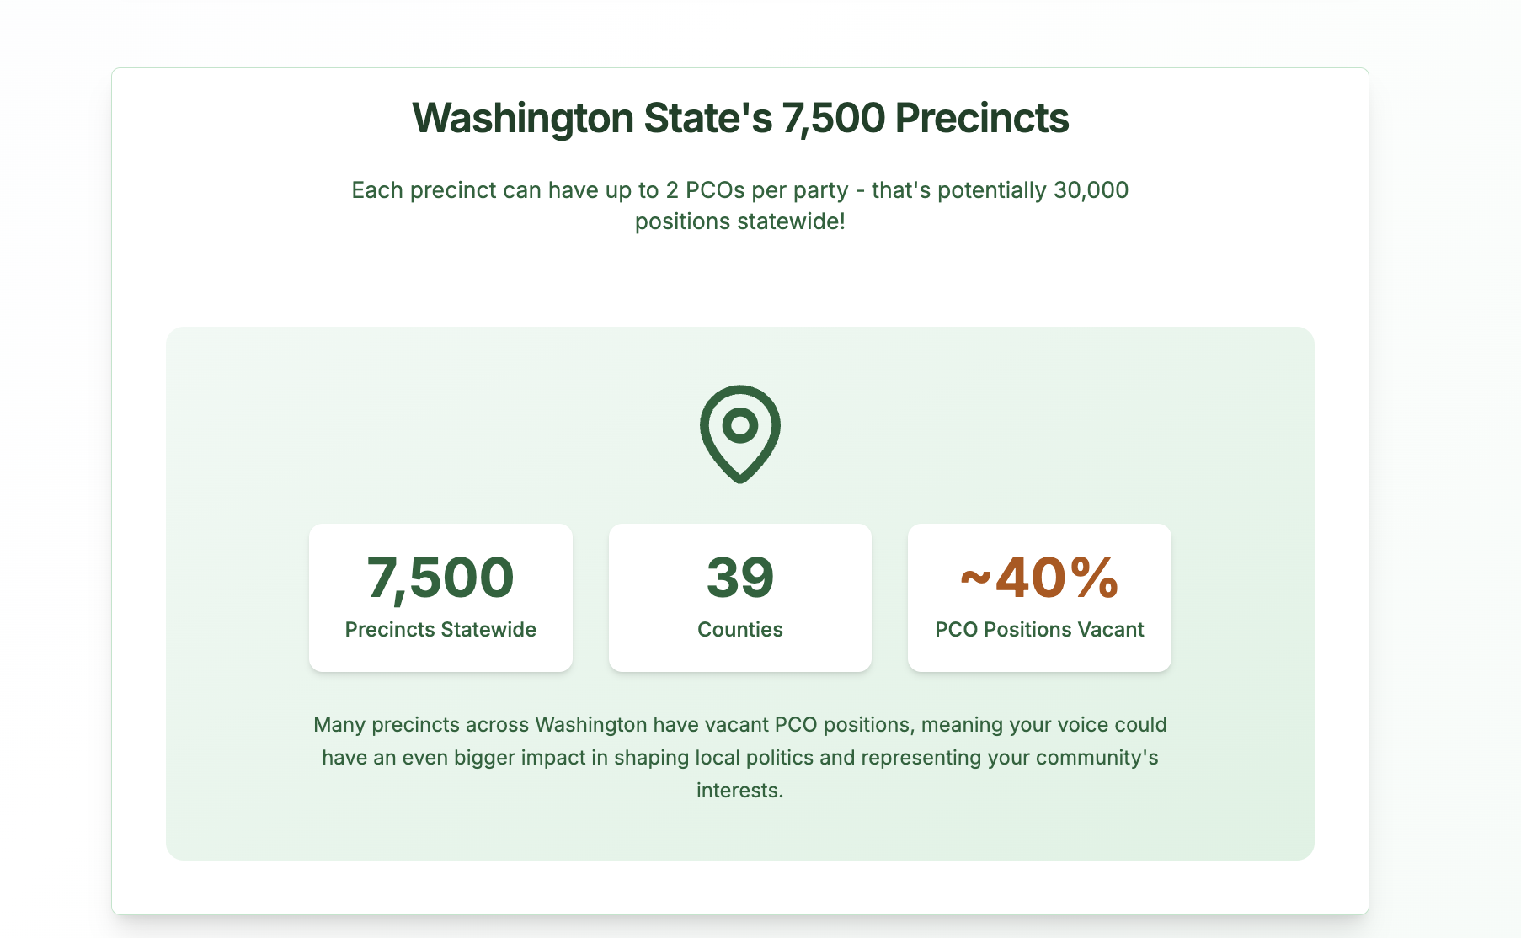

### **1.4 Call to Action**

A powerful close invites users to make a tangible difference:

* **Text**: “Being a PCO is one of the most direct ways to influence politics at the grassroots level. It’s a volunteer position that requires just a few hours per month but can have a lasting impact on your community.”
* **Buttons**: Provide immediate access to:  
  + [*Learn How to Become a PCO*](https://tvw.netlify.app/become-pco)
  + [*Find Your Precinct*](https://tvw.netlify.app/find-precinct)

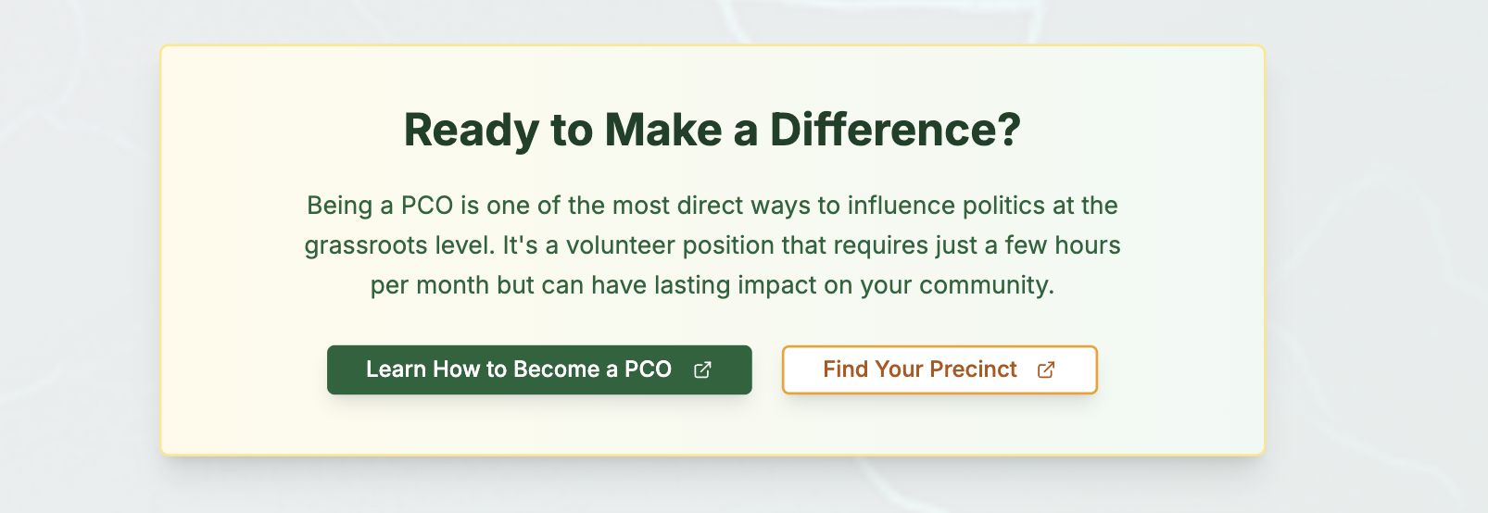

| **Element** | **Description** |
| --- | --- |
| **Purpose** | Educates users on what a PCO is and why the role matters |
| **Audience** | Young voters, civic educators, community leaders, and new stakeholders |
| **Page Structure** | Clear, segmented into outreach, leadership, and advocacy tasks |
| **Engagement Strategy** | Includes stats showing opportunities and vacant roles |
| **Call to Action** | Encourages civic action, links to becoming a PCO and locating precincts |

## **2. Feature 2: Party Platforms**

This page helps users understand and compare the policy positions of Washington’s major political parties, giving them a foundation to make informed civic and political decisions.

### **2.1 Page Title and Introduction**

* **Header:** “Compare Party Positions” clearly signals the page's purpose
* **Tagline:** “Understanding where the major parties stand on key issues helps you make informed decisions about which party aligns with your values as a PCO.”

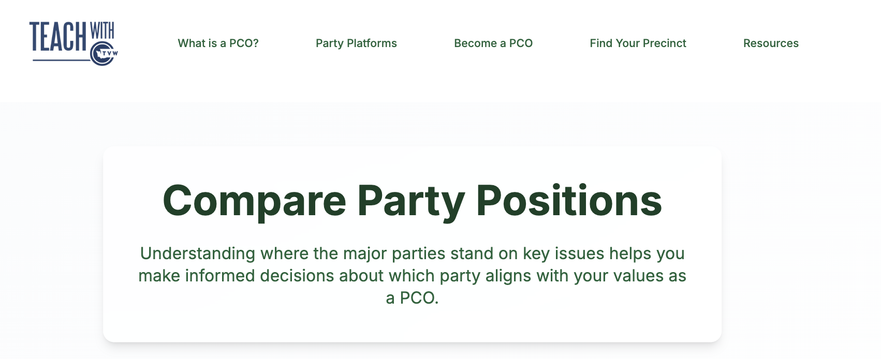

### **2.2 Core Content**

The page organizes party stances across several core issues in a side-by-side format.

**Healthcare**

* *Democrats:* Support universal healthcare, expand Medicaid, protect reproductive rights
* *Republicans:* Favor market-based solutions, reduce government involvement, emphasize religious freedom

**Economy & Jobs**

* *Democrats:* Raise minimum wage, support unions, invest in sustainable infrastructure
* *Republicans:* Lower taxes, reduce regulations, prioritize small businesses

**Education**

* *Democrats:* Increase public school funding, make college more affordable
* *Republicans:* Emphasize school choice, protect parental rights, limit federal oversight

**Environment**

* *Democrats:* Push for climate action, clean energy, environmental justice
* *Republicans:* Balance environmental protection with economic development and energy independence

**Immigration**

* *Democrats:* Pathways to citizenship, protect DACA, humanitarian reform
* *Republicans:* Strengthen border enforcement, merit-based immigration, prioritize national security

**Criminal Justice**

* *Democrats:* Promote reform, rehabilitation, community policing
* *Republicans:* Emphasize public safety, tough-on-crime, victims’ rights

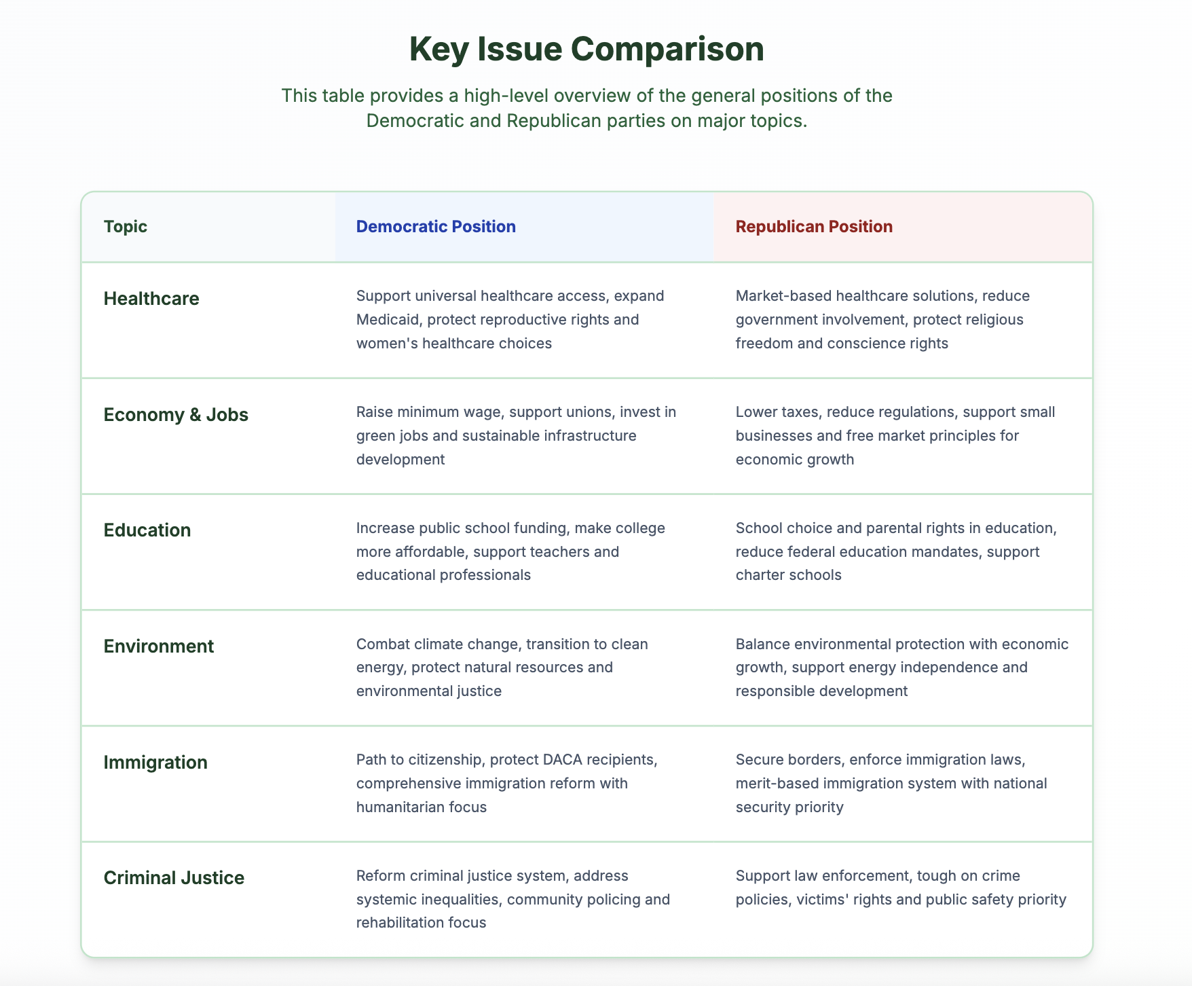

**Links to Party Platforms**

* [*Washington State Democratic Party Platform*](https://wadems.org/)
* [*Washington State Republican Party Platform*](https://wagop.org/)

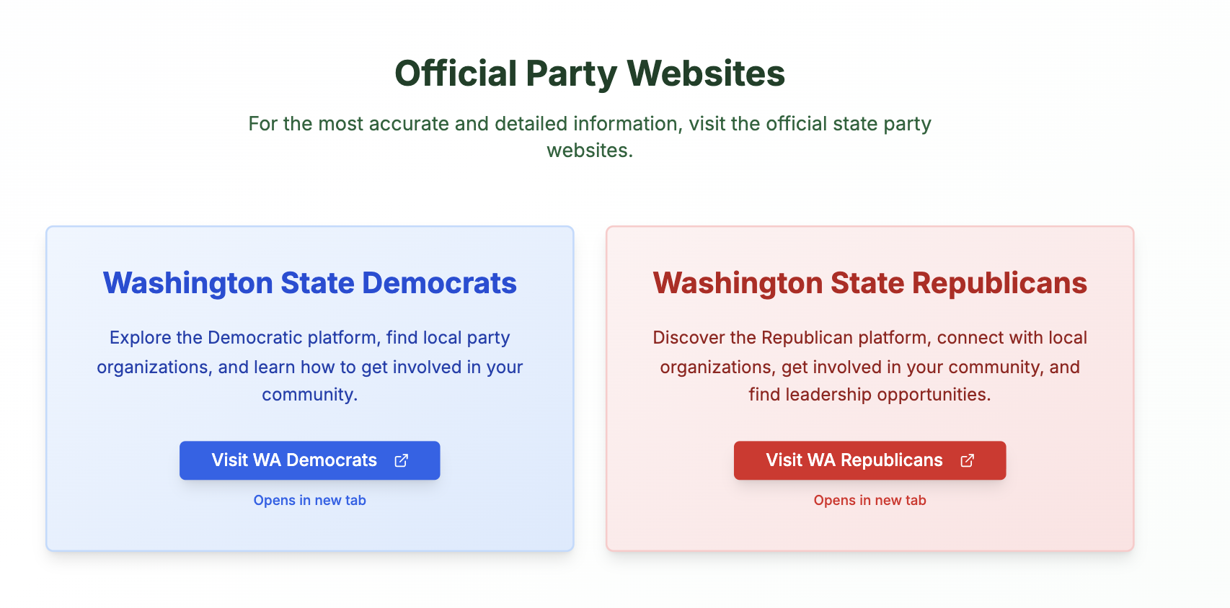

### **2.3 Impact and Opportunity**

* Helps users quickly compare issue-by-issue policy differences
* Gives future PCOs context for aligning with a party and understanding its values
* Builds awareness of how grassroots representatives connect to broader party priorities

### **2.4 Call to Action**

* **Text:** “Ready to Get Involved? Now that you understand the party positions, learn how you can become a PCO and help shape your party’s future in your community.”
* **Buttons:**
  + [*How to Become a PCO*](https://tvw.netlify.app/become-pco)
  + [*Find Your Precinct*](https://tvw.netlify.app/find-precinct)

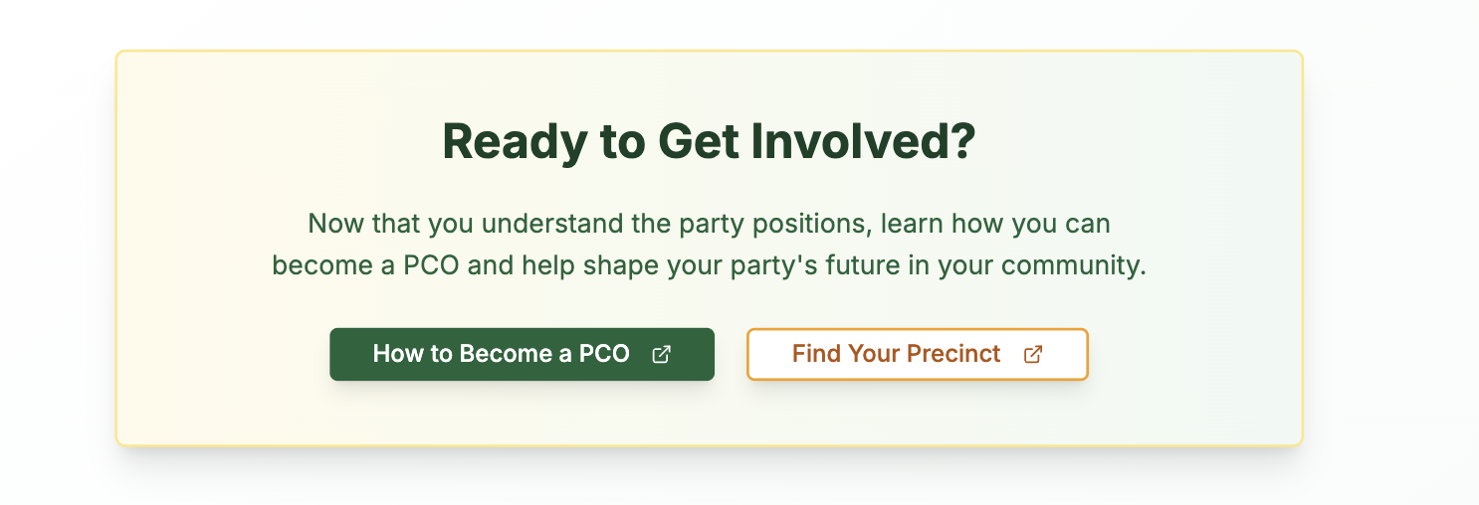

| **Element** | **Description** |
| --- | --- |
| **Purpose** | Compare major party platforms to inform and prepare civic participants |
| **Audience** | Prospective PCOs, students, new voters, educators, civic leaders |
| **Page Structure** | Side-by-side issue comparisons, links to official sources |
| **Engagement Strategy** | Simplifies complex political ideas into accessible, plain-language points |
| **Call to Action** | Encourages users to take the next step toward becoming a PCO or finding their precinct |

## **3. Feature 3: Become a PCO**

This feature guides users through the process of becoming a Precinct Committee Officer using an interactive timeline, eligibility checker, and myth-busting module. The flow empowers potential volunteers to plan strategically and act with confidence.

### **3.1 Page Title and Introduction**

* **Header:** “Your Path to Becoming a PCO” clearly signals the guide’s focus
* **Tagline: “***Follow this interactive guide to understand the requirements and process for becoming a Precinct Committee Officer in Washington State.”*

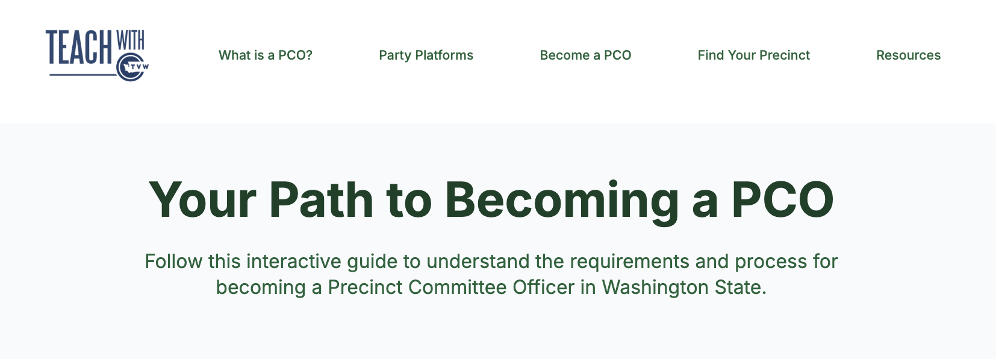

### **3.2 Core Content**

**Check Your Eligibility**

This feature lets users verify if they meet the basic criteria to become a PCO. The table below outlines each possible user input scenario, the corresponding message shown, and any follow-up call-to-action or guidance for the user.

| **User Input** | **System Output** | **Follow-Up** |
| --- | --- | --- |
| **Under 18 and Registered to Vote** | *“You must be 18 or older to be a PCO. You can still Volunteer!* | Encourages the user to get involved by volunteering until they reach eligibility age. No prompt to register since the user indicated previous registration |
| **Under 18 and Not Registered to Vote** | *“You must be 18 or older to be a PCO. You can still Volunteer!* | Encourages the user to get involved by volunteering until they reach eligibility age. No prompt to register since the user indicated previous registration |
| **18 or Older and Not Registered to Vote** | ***“****You must be a registered voter to be a PCO. You can register online”* | Provides a prompt to register to vote via a link to the state voter registration portal |
| **18 or Older and Registered to Vote** | *“You**meet the basic requirements to become a PCO. See the timeline below”* | Offers next-step guidance for becoming a PCO. If it is an election year **and** before the filing deadline, the user is advised to file as a candidate for PCO (elected PCO). Otherwise, the user is guided on how to be appointed to a vacant PCO position |

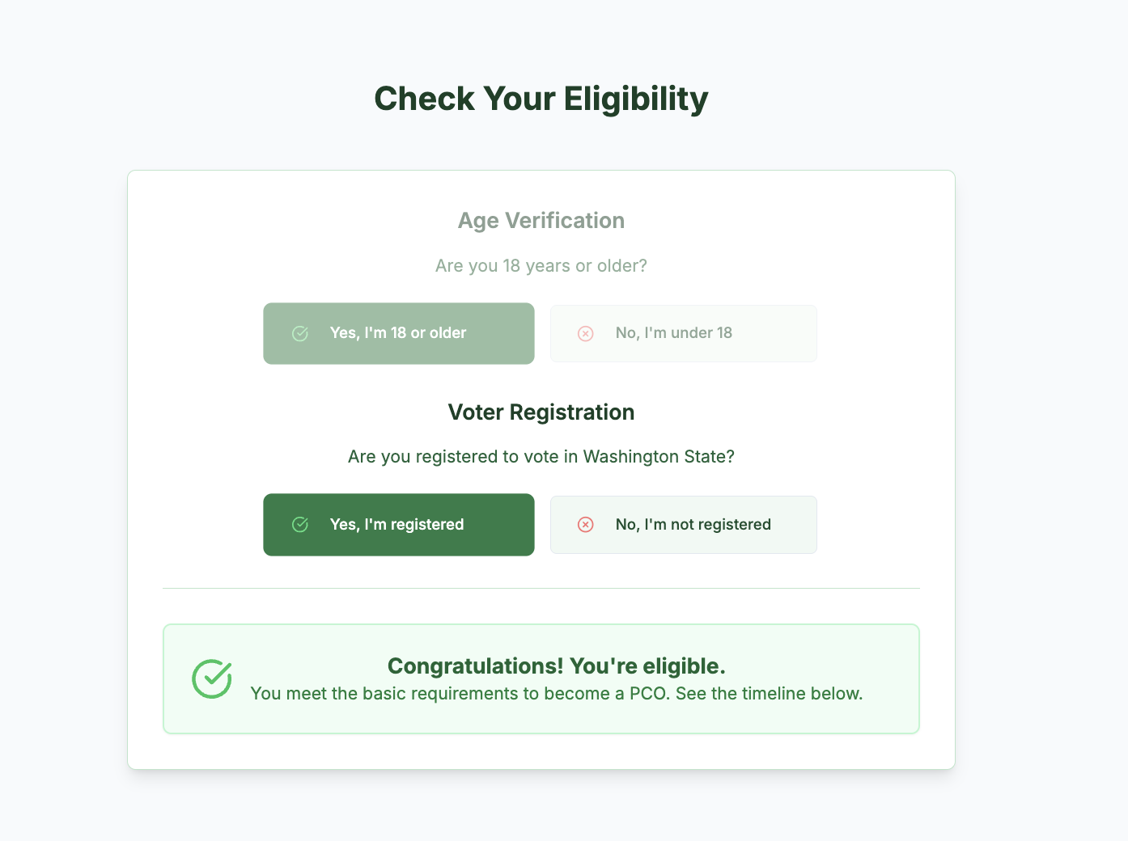

**Timeline to Get Elected!**

* **Research & Prepare (Anytime)**
  + Find your precinct number and boundaries
  + Attend local party meetings to network
  + Learn the key issues in your community
  + Connect with current PCOs for advice
* **Filing Period - May (Election Years)**
  + Official filing week is typically in May of even-numbered years
  + File your candidacy with your county elections office
  + There is no fee to file for PCO
* **Campaign (if needed) - Summer**
  + Many PCO positions are uncontested
  + If another person files, you’ll need to campaign
  + Talk to your neighbors and ask for their vote
* **Election - August (Election Years)**
  + Your name will appear on the Primary Election ballot
  + Only voters in your precinct can vote for you
  + The winner is decided in the August Primary
* **Take Office - December 1st** 
  + If you win the election, you are officially certified
  + Your two-year term as a PCO begins on December 1st
  + You become a voting member of your local party organization

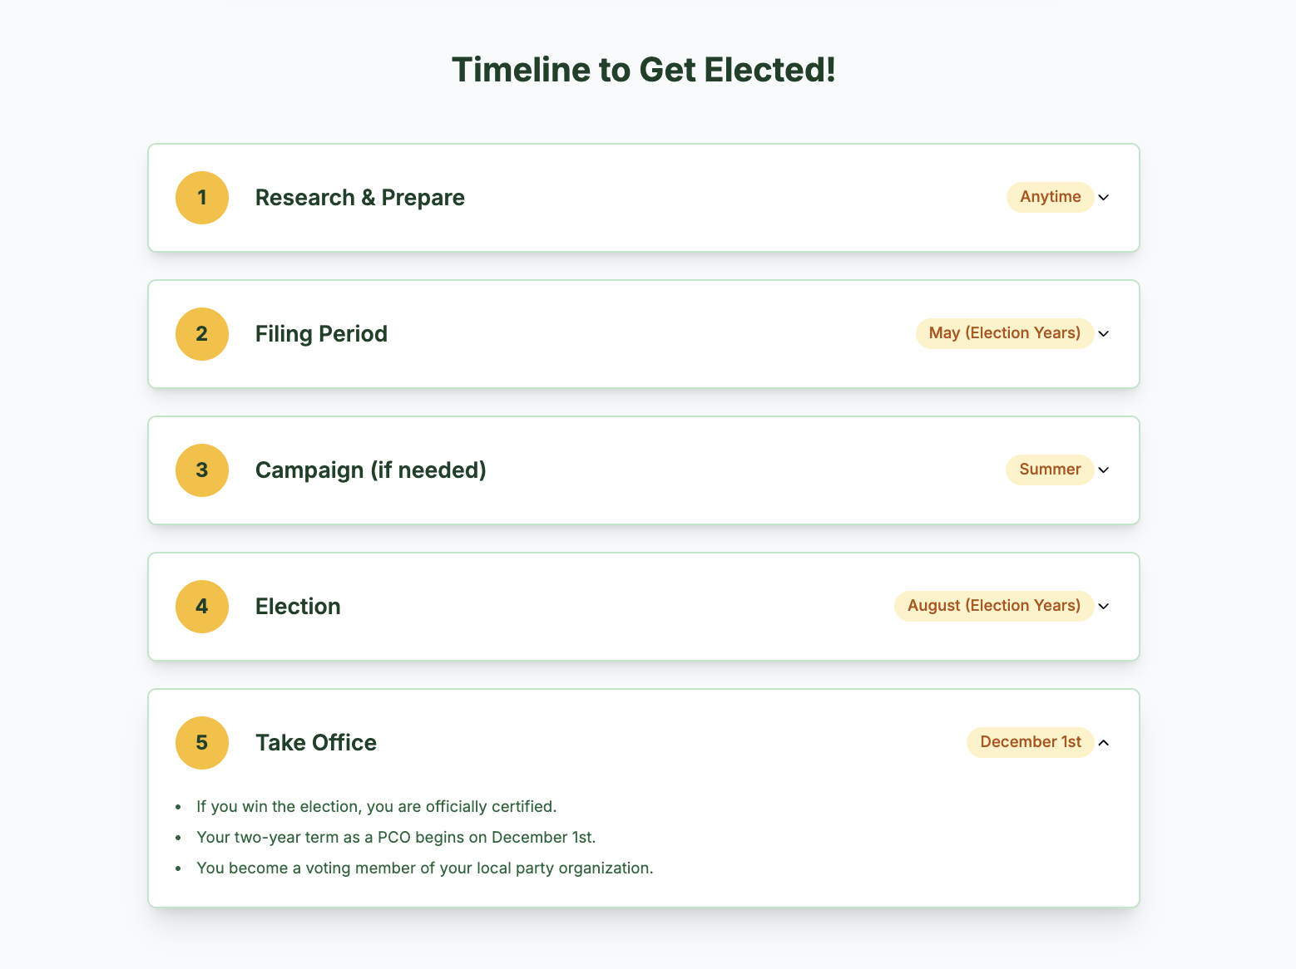

**PCO Myth vs. Fact**

This module addresses common misconceptions about becoming a PCO to educate and encourage end users to pursue PCO positions.

| **System Prompt** | **User Input** | **System Output** |
| --- | --- | --- |
| **You have to be 18 to be an Elected PCO** | Fact | *“Correct! The answer is FACT! To be an elected PCO, you must be a registered voter, which requires you to be 18. However, anyone can be an Acting PCO regardless of age!”* |
| **You have to be 18 to be an Elected PCO** | Myth | *“Incorrect. The answer is FACT! To be an elected PCO, you must be a registered voter, which requires you to be 18. However, anyone can be an Acting PCO regardless of age!”* |
| **You have to pay a fee to run for PCO** | Fact | *“Incorrect. The answer is MYTH! Filing to become a PCO is free because it is an unpaid, volunteer party position.”* |
| **You have to pay a fee to run for PCO** | Myth | *“Correct! The answer is MYTH! Filing to become a PCO is free because it is an unpaid, volunteer party position.”* |
| **Being a PCO takes up all your free time** | Fact | *“Incorrect. The answer is MYTH! The time commitment is flexible. The handbook suggests a few hours a month, but you can contribute as much or as little time as you have.”* |
| **Being a PCO takes up all your free time** | Myth | *“Correct! The answer is MYTH! The time commitment is flexible. The handbook suggests a few hours a month, but you can contribute as much or as little time as you have.”* |
| **PCOs have to donate a lot of money** | Fact | *“Incorrect. The answer is MYTH! There is no requirement to donate. A PCO’s main role is to organize and connect with voters, not to be a fundraiser.”* |
| **PCOs have to donate a lot of money** | Myth | *“Correct! The answer is MYTH! There is no requirement to donate. A PCO’s main role is to organize and connect with voters, not to be a fundraiser.”* |
| **You can only be an Elected PCO** | Fact | *“Incorrect. The answer is MYTH! Besides being elected, you can also be appointed PCO (if a seat is vacant) or an acting PCO (to help organize a vacant precinct).”* |
| **You can only be an Elected PCO** | Myth | *“Correct! The answer is MYTH! Besides being elected, you can also be appointed PCO (if a seat is vacant) or an acting PCO (to help organize a vacant precinct).”* |

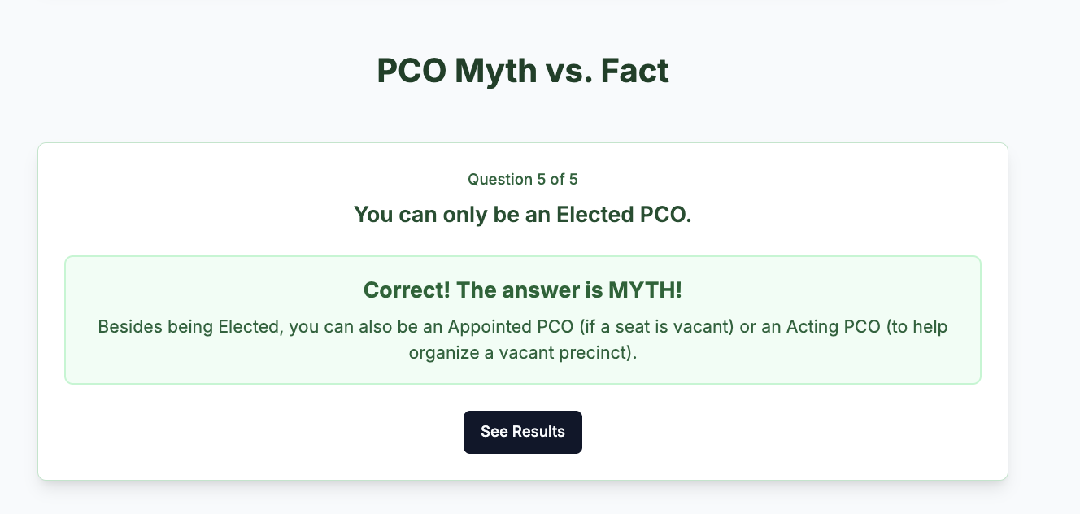

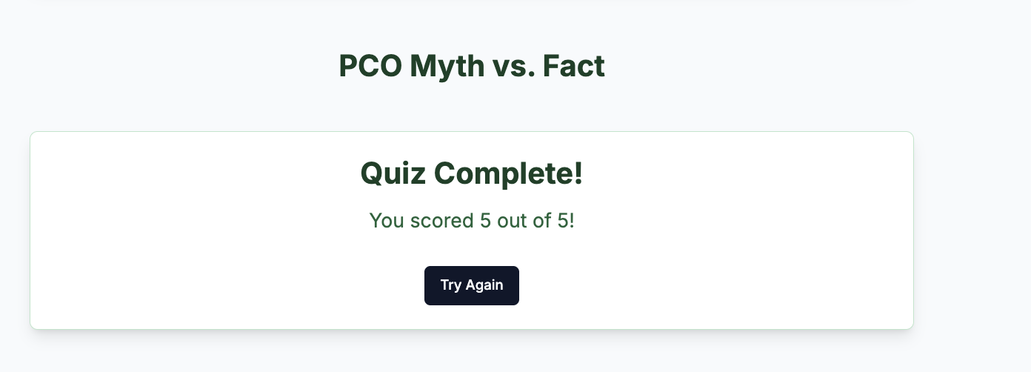

### **3.3 Impact and Opportunity**

* Guides users from eligibility check to concrete action steps
* Underscores large number of vacant PCO positions statewide
* Emphasizes accessibility of the role with minimal time commitment
* Encourages diverse community leadership and representation

### **3.4 Call to Action**

* **Text:** “Ready to Take the Next Step? Find your precinct and see if there are current PCO vacancies in your area. You might be able to get appointed before the next election!"
* **Buttons:**
  + [*Find Your Precinct*](https://tvw.netlify.app/find-precinct)
  + [*Get Resources*](https://tvw.netlify.app/resources)

## **4. Feature 4: Find Your Precinct**

This feature helps users locate their precinct and connect with current PCOs in their county, while pointing them to official resources for voter registration and verification.

### **4.1 Page Title & Introduction**

* **Header**: “Locate Your Precinct” clearly indicates the page’s function
* **Tagline**: “This tool helps you find PCOs in your county. For official voter registration and precinct information, please use the official resources below.”

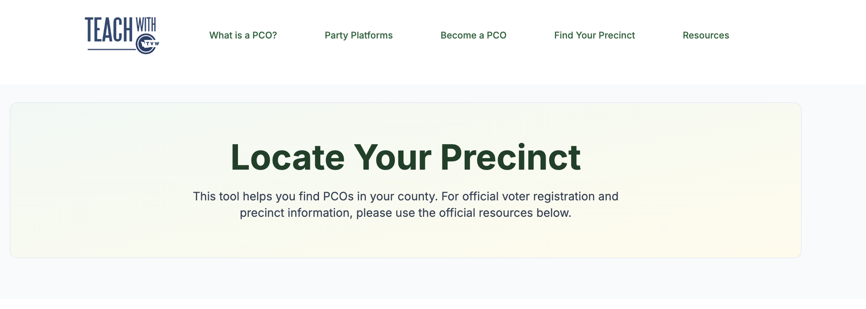

### **4.2 Core Content**

**County PCO Directory**

Users can utilize this directory to pinpoint and contact their local PCOs based on **county**, **name**, **precinct**, **email**, and **address** inputs.

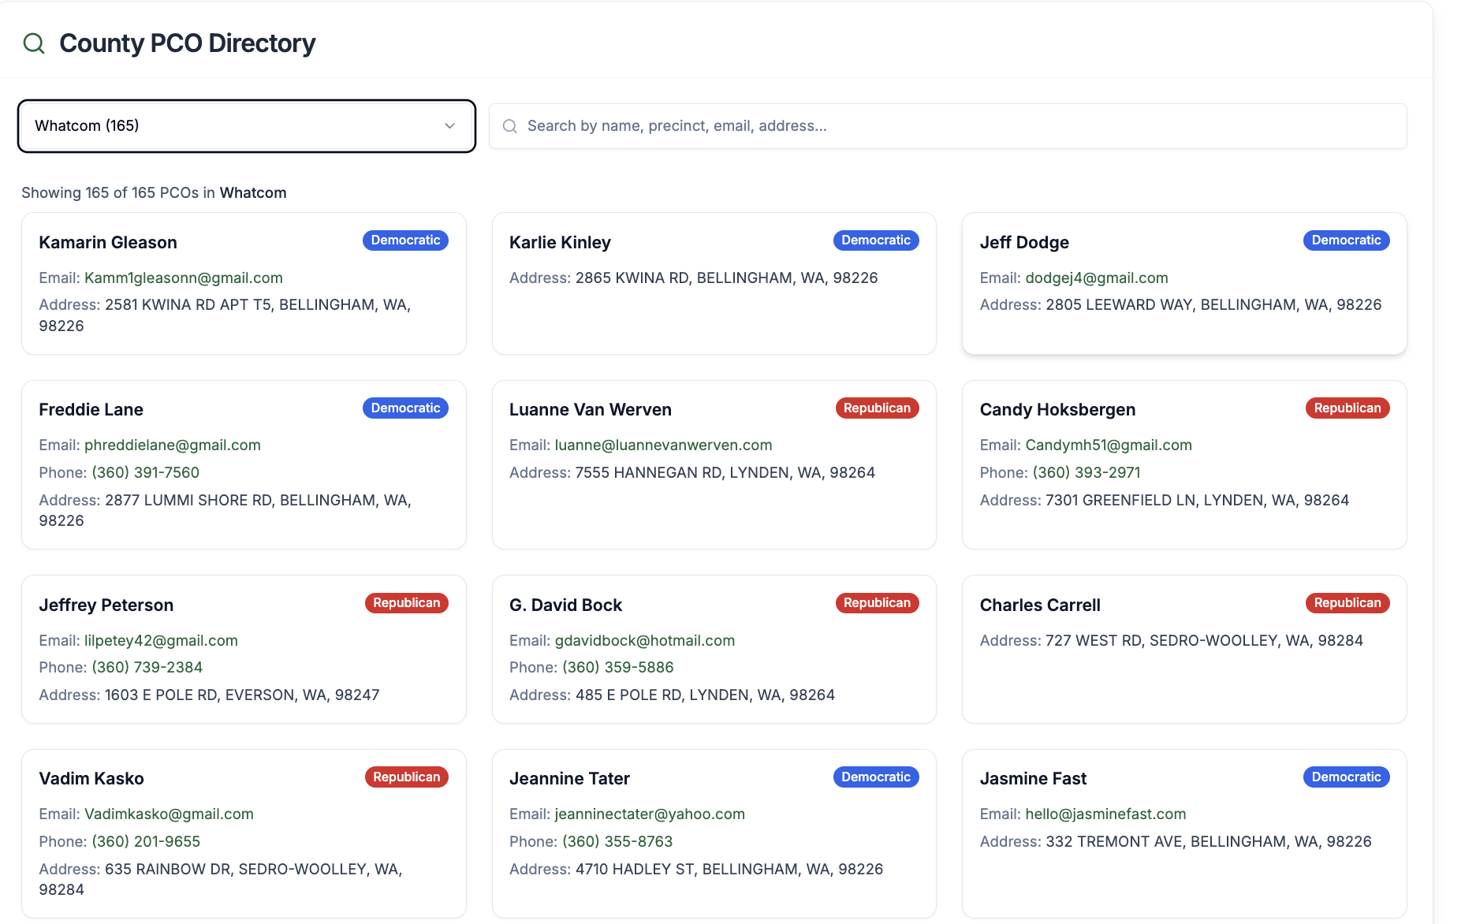

**Official Precinct Resources**

* [*Secretary of State*](https://www.sos.wa.gov/elections)
  + Official voter information, precinct maps, and election details from Washington State
* [*VoteWA.gov*](http://votewa.gov)
  + Find your polling location, check registration status, and access your voter guide

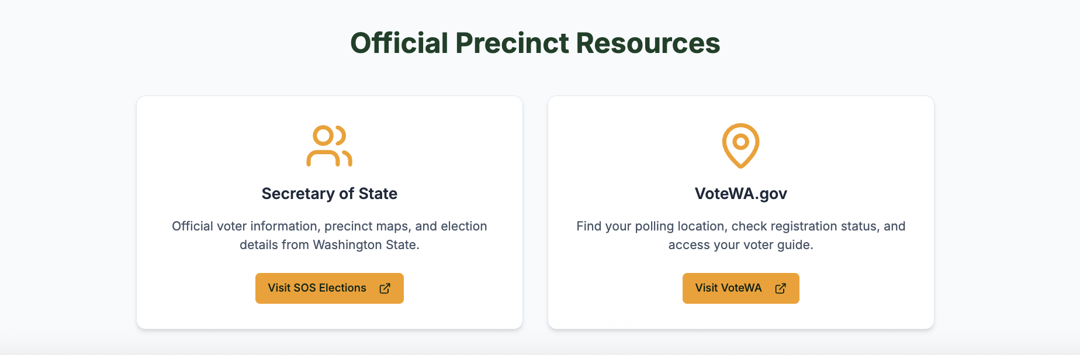

**4.3 Impact & Opportunity**

This section uses compelling statistics to underscore the significance and scarcity of PCOs:

* Helps users confirm their official registration and voting precinct with accuracy
* Provides a simple pathway to identify whether their precinct has an active PCO
* Bridges state election resources with grassroots organizing, reinforcing civic trust

## **5. Feature 5: Resources**

This feature serves as a resource hub, providing users with videos, downloads, FAQs, and external links to support civic engagement and PCO participation.

### **5.1 Page Title & Introduction**

* **Header:** “Video Resources”

### **5.2 Core Content**

The Resources page is organized into helpful categories for different user needs:

#### **Video Resources**

* [*“What is a PCO?”*](https://www.youtube.com/watch?v=3UtOorj4RJ8&embeds_referring_euri=https%3A%2F%2Ftvw.netlify.app%2F&source_ve_path=MjM4NTE)
* [*“How to Become a PCO”*](https://www.youtube.com/watch?v=SNcMl8hlyow&embeds_referring_euri=https%3A%2F%2Ftvw.netlify.app%2F&source_ve_path=MjM4NTE)

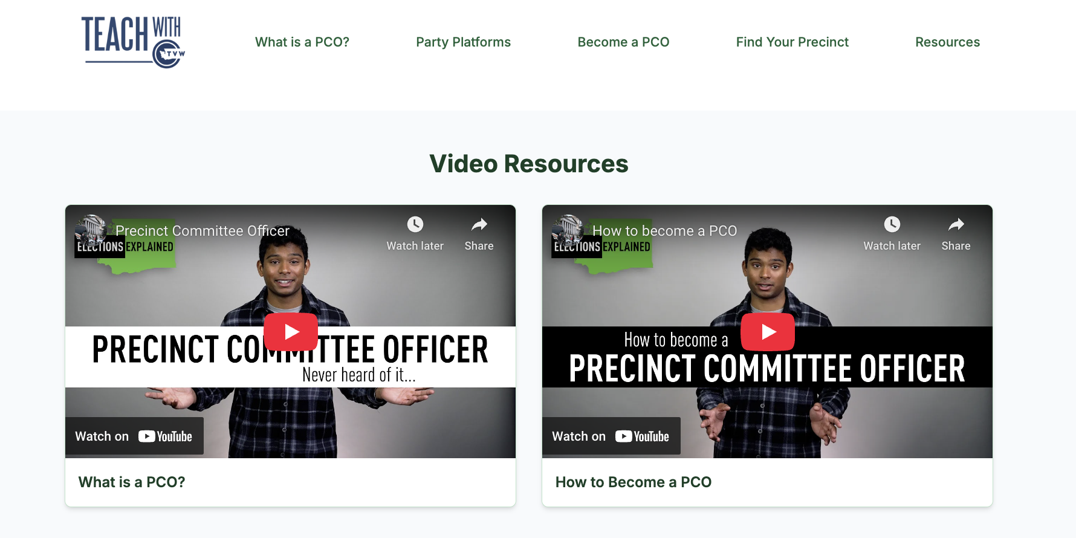

#### **Documents & Downloads**

* **PCO Handbook 2024:** Guide to PCO duties, rights, responsibilities (PDF, 2.3 MB)
* **Filing Requirements Checklist:** All filing essentials (PDF, 450 KB)
* **County Contact Directory:** Info for all 39 county party offices (PDF, 1.1 MB)
* **Sample Campaign Materials:** Templates for flyers, door hangers, and social media posts (ZIP, 5.7 MB)

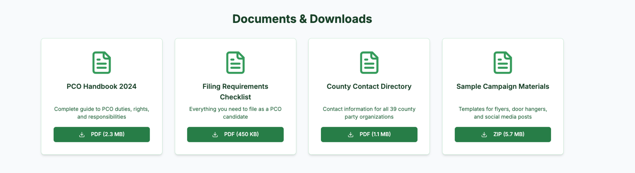

#### **Frequently Asked Questions**

* **How much time does being a PCO require?** 
  + Most PCOs spend 2-5 hours per month on their duties. This includes attending monthly party meetings, occasional community events, and staying informed about local issues. During election seasons, you might spend a bit more time helping with campaigns or voter outreach.
* **Do I need political experience to be a PCO?**
  + No! Many successful PCOs start with no political experience. The role is designed to be accessible to everyday citizens. Your passion for your community and willingness to learn are more important than prior experience.
* **What if I disagree with some party positions?** 
  + It's normal to not agree with every party position. As a PCO, you help shape the party's direction at the local level. Your voice and perspective can influence party priorities and candidate selections in your area.
* **Can I be a PCO if I’m in college or move frequently?**
  + You need to be a resident of your precinct to serve as PCO. If you're in college locally, you can serve. If you move, you'd need to step down and could potentially run in your new precinct. Some students wait until they're more settled to run.
* **What happens if no one runs against me?**
  + Many PCO positions are uncontested! If you're the only candidate, you'll automatically win. This is actually very common - about 40% of PCO positions in Washington are vacant.
* **How do I connect with other young PCOs?**
  + Both major parties have young professional groups and social media communities. Your county party can connect you with other PCOs in your area. Many counties also have mentorship programs for new PCOs.
* **What if I want to switch parties later?** 
  + You can only serve as a PCO for one party at a time. If you want to switch parties, you'd need to resign your current position and could potentially run for the other party in the next election cycle.
* **Are there any costs involved in being a PCO?**
  + Being a PCO is a volunteer position, so there are no fees to run or serve. Some PCOs choose to spend a small amount on campaign materials like flyers, but this is not required. Many local parties offer resources to help with these costs.

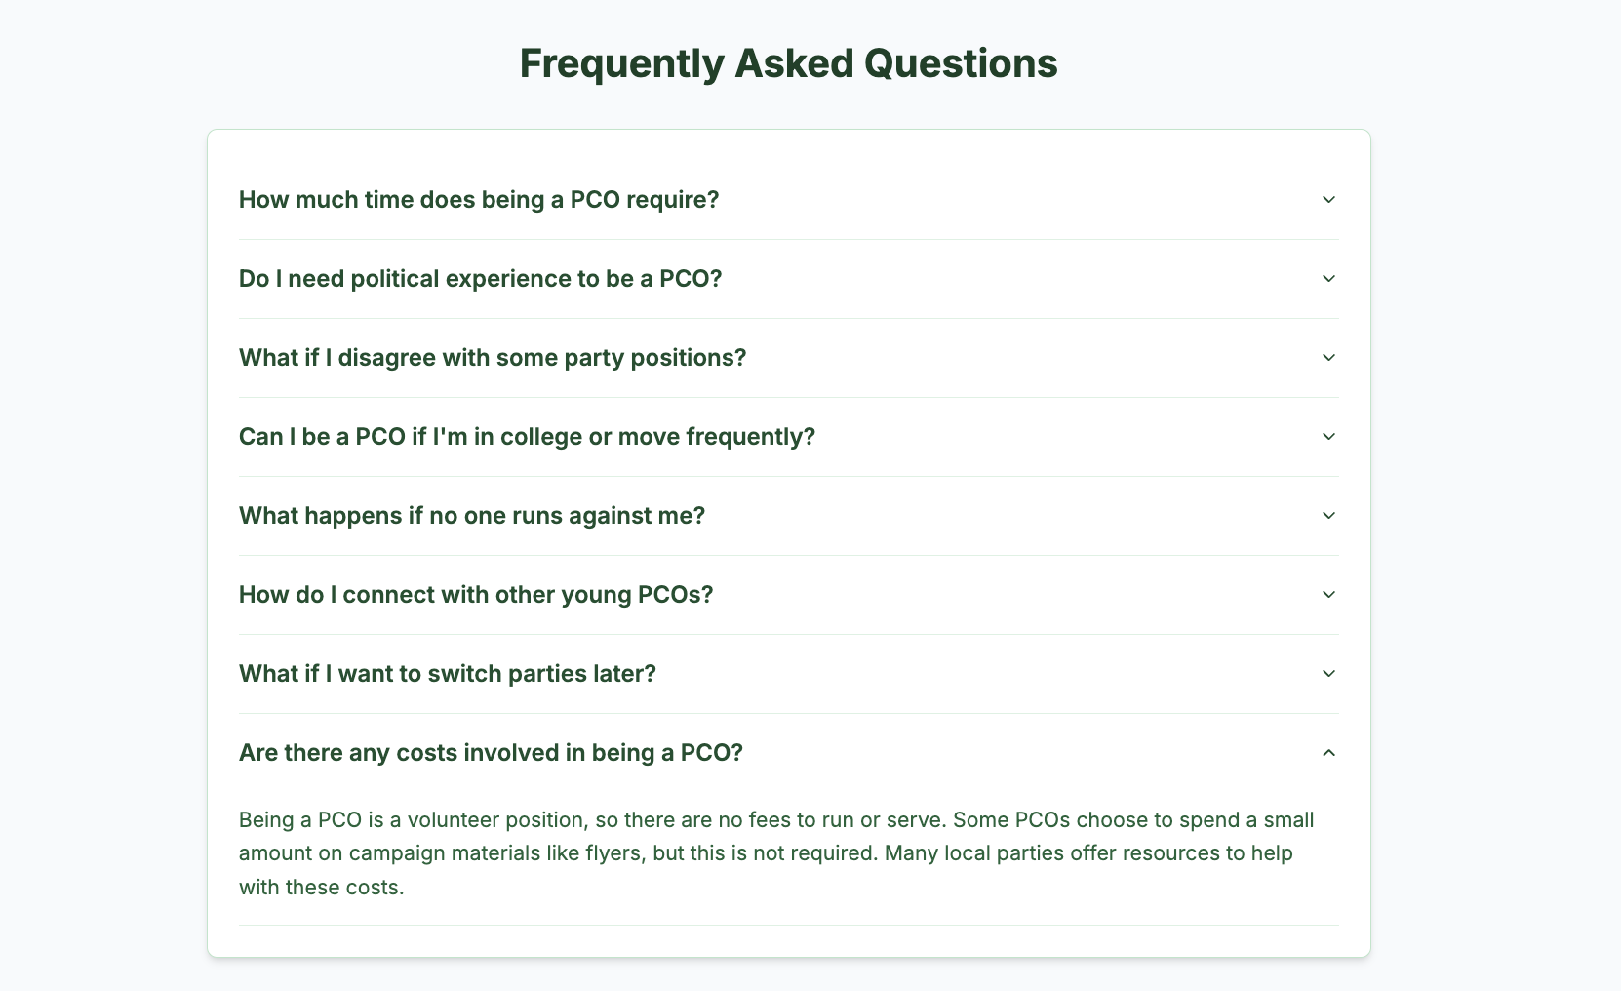

#### **Official External Links**

* [*WA Secretary of State:*](https://www.sos.wa.gov/elections)Election info, candidate filing, voter resources
* [*WA State Democrats*](https://wadems.org/)*:* Training, materials, local contacts
* [*WA State Republicans:*](https://wagop.org/) Resources and county contacts

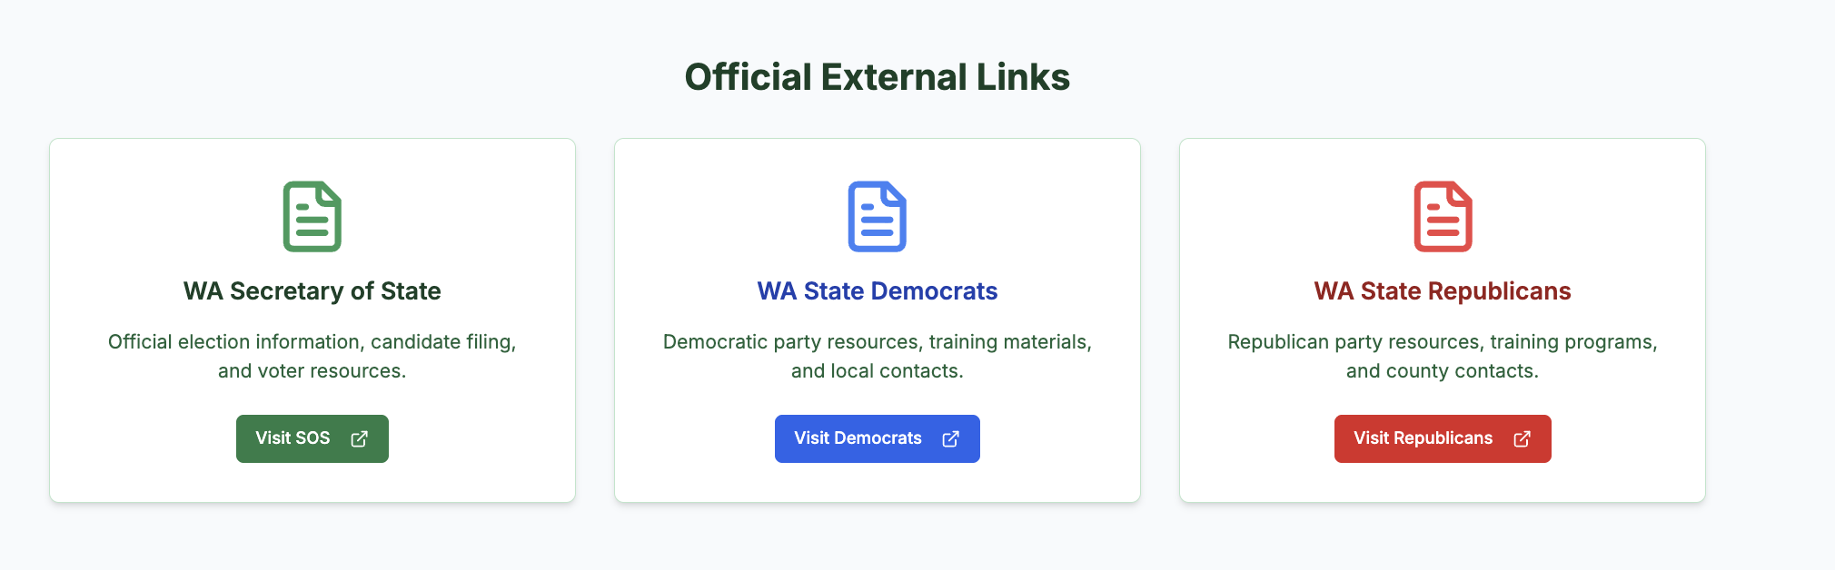

### **5.3 Impact and Opportunity**

* Empowers users with comprehensive tools and materials
* Supports both individual learning and group work (e.g., educators or civic organizations)
* Integrates local and state-level resources, creating a one-stop hub for civic participation

### **5.4 Call to Action**

**Text:** “Still Have Questions? The best way to learn more is to get involved! Attend a local party meeting, talk to current PCOs, and see democracy in action.”

**Buttons/Links:**

* [*Find Your Precinct*](https://tvw.netlify.app/find-precinct)
* [*Start Your Journey*](https://tvw.netlify.app/become-pco)

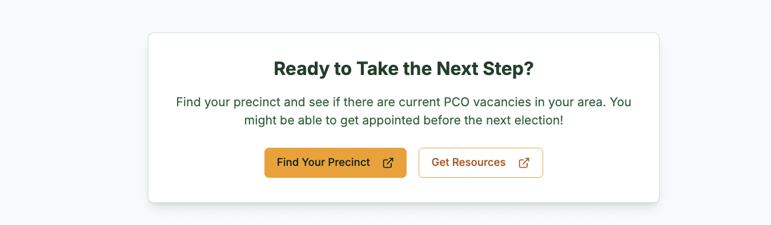

**IV. Troubleshooting and Support**

* **Page not loading**: Refresh the browser, or clear your cache if the problem persists
* **Search tool not returning results**: Verify the precinct or district entered is correct
* **Access issues**: Ensure you are using an updated browser such as Chrome, Firefox, or Safari
* **Further support**: Contact [support email or stakeholder contact] for technical assistance

**V. Best Practices for Stakeholders**

* Use the site as both a learning tool and a community engagement resource
* Encourage younger audiences to interact with the educational content to increase civic literacy
* Leverage the search tools in workshops, classrooms, or community events to demonstrate grassroots political involvement
* Provide feedback to the development team to improve usability and accessibility